Betty Smith
This is an edited transcript of conversations between Mrs Betty Smith of Ravenglass and Neil Robson in August/September 2026. The interview was carried out over six sessions and ranged over Betty’s 94yrs – so far. The audio recordings are roughly chronological but Betty’s recollections didn’t all come up in strict date order so the transcript isn’t a verbatim record but is edited to improve the flow and to aid understanding.

Family Background:
NR: Can we start off by telling us a bit about your family background:
BS: My Dad Walter Cowan’s parents lived on Main Street Ravenglass next door to Jack Pharoah the garage. Now Dunlin Cottage. They had twelve children which I suppose was normal in those days. Three of the boys went to WWI. Only one came back alive. Grandad died when I was about three and Grandma when I was 20.
The two who didn’t come back are listed on the Muncaster war memorial?
Yes, they were Bob and William. In their very early 20s. They’d been in France. I think one of them had been injured and came back to England. He was allowed to come back home to recuperate and he said to his mother “It’s awful out there. I don’t want to go back and I don’t think I’ll ever come home again.”
One of them has his name on the Thiepval memorial. We planned to go and see that but the years passed and I never got there. But we never forget them. Every year I get a little cross that the British Legion send me. I sign it and send it back and they place it outside Westminster Abbey every year which is very nice but the boys aren’t there are they?
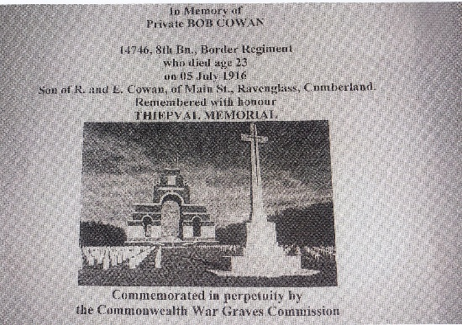
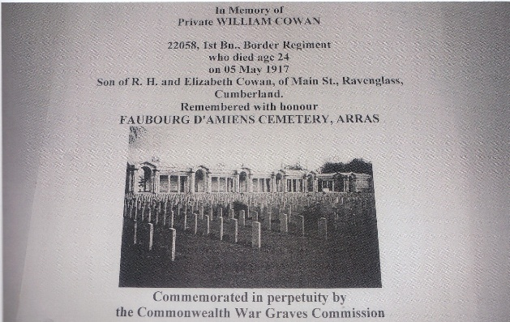
Muncaster War Memorial was unveiled on 28th September 1922 by The Earl of Errol KT, CB, TD.
Edward Prince of Wales called at Muncaster on 29th June 1927 during a tour of the North West. Mrs Elizabeth Cowan, my Granny, met him as representative of people who lost sons in the First World War. (I have a photo of the event but of very poor quality)
The rest of the family boys worked mostly on the railway. My dad was a plasterer, had his own business and his dad worked with him. In around 1996 the church at Muncaster underwent some refurbishment and I was able to climb scaffolding to touch the plaster ceiling that had been laid around 60yrs previously by my father and probably untouched since then.
Mother Ada came from Wasdale. Her parents were Henry and Ada Tyson which is quite a common name in these parts. She was one of 9 children, six girls and three boys. They owned Greendale Farm that they moved to when Mum was about 4 or 5. Mainly sheep. When you add that to Dad’s 12 I had a lot of Aunts and Uncles.
Somehow Mum heard of a job in the laundry at Muncaster. She came on the train and walked up the road to the castle. As it happened Dad was around on his bike. He thought, “I’ll have some of that” and followed her up the road.
Mother got the job in the laundry. They had a big wooden mangle and old Jack who looked after the horses would turn the handle for them. Mother would be there feeding in sheets and Jack would say “Carry on Ada, I’ll tell you when your fingers are stuck.”
So Mum and Dad got married and, after a bit I appeared.
Where were they living when you entered the world.
They were living at 9 Main Street. Grandparents had bought it and being builders and plasterers they were able to do it up. It’s now called Ada’s Cottage. It’s not named after my mother but the little baby of the man that now owns it.
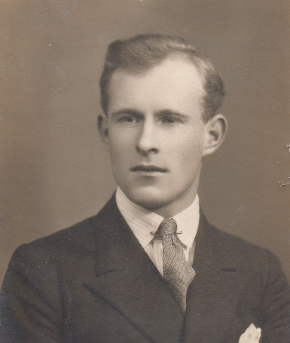
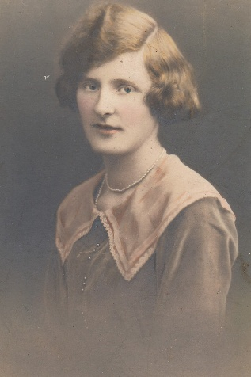
I was born on Christmas Day 1931 at 7:30 in the evening and my mother joked about it as long as she lived that she never got any Christmas Dinner that year. She didn’t do much better the following year because my brother Robert was born on December 9th. My sister Ann arrived 11 years later in 1942
Ada and Walter Cowan Betty’s Mum and Dad

Childhood Illness:
When I was six I developed Rheumatic Fever. That can affect your tonsils so I’m told. I had to go to Carlisle hospital to have my tonsil out. Our doctor, Dr Lloyd took me in his car – you wouldn’t get that now. I had my tonsils out and came home but I had to be wheeled round in a pushchair for quite a few months because it was thought it could affect the heart and walking and running wouldn’t be good. Any water I drank had to be boiled. I couldn’t go to school. All the other children laughed at me and said I was a baby. Anyway they said I’d grow out of it and I did because I’m still here!
There would be no hospital at Whitehaven.
No you had to go to Carlisle. It’s a long way now but in those days nobody had cars apart from the doctor. He was a nice man. I liked him.
Dad’s Cancer:
My father developed cancer when he was 31 and I was seven. My brother Robert and I wouldn’t have been old enough to have been told about that until much later.
A little tiny pea of a lump behind his ear. They cut him down and under his arm and he couldn’t lift his arm so he couldn’t plaster but it also meant he couldn’t go to war when WWII started around that time. He went to work at Drigg at the munitions factory. He was called a Danger Building Visitor. A fancy name for somebody who walked around. They told the locals they were building a jam factory.
I don’t know when cancer hit my Dad again – we weren’t told – but he lived to see the end of the war. He died in August 1946 aged 38 and I miss him to this day.
Muncaster School:
Is there anything else interesting before the war broke out?
Yes, when I was at Muncaster school before the fever we were all taken out of school one day and taken over the road to Muncaster Main Gate and lined up either side of the drive for maybe a couple of hundred yards because Queen Mary was paying a visit to the castle. Later, when war had started we were taken over there again and had to practice crouching down behind the wall – just in case there was an air raid.
The school was up at Muncaster in your day not in the village?
It was in the village in my father’s day when families tended to be bigger but when I went it was up at Muncaster.
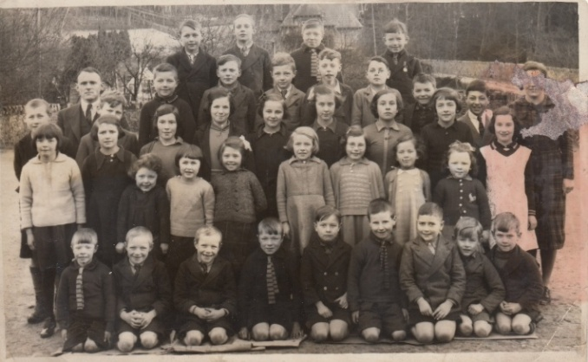
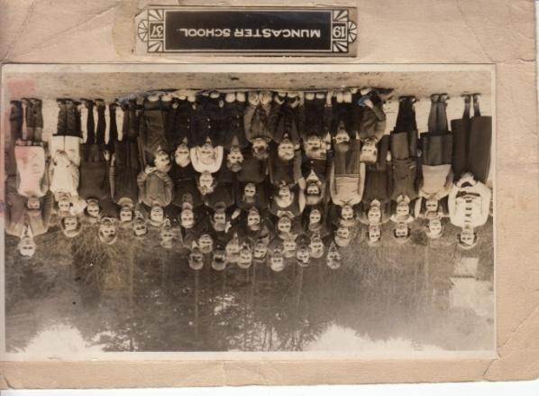
I started at Muncaster School aged 5. The head teacher then was Mr. Rich later Mr. Sarginson. I have photos of the school pupils in 1937 & 38 with me in the middle. There were around 40 pupils from Ravenglass village and the surrounding area, farms and so on.
Muncaster School in 1937 (left) and 1938 (right) with Betty circled

Two classes. Up to 8 or 9 than up to 14 when we left. Teacher was Miss Hetherington. In my last couple of years Mrs. Mason taught us girls knitting and sewing.
We walked up the road from Ravenglass, maybe a mile and a bit, every day, rain, hail or shine up what is now a busy road but much quieter then.
There were a lot of children in the village when you were at school so you’d have lots of playmates. What sort of things did you get up to when you weren’t at school
We played rugby on the green although this was before it became a registered Village Green. Just a grassy area. We didn’t know the proper rules but we made them up. It was boys against girls or mixed.
Then we had Boy Scouts and Girl Guides. We often went off camping. I remember going to Eskdale camping quite a few times because the vicar’s daughter lived at the vicarage and there was a field. The Boy Scouts camped in the field next to the Ratty station at Dalegarth and we would get together for sing-songs and things
War Time:
I don’t remember when a lot of evacuees from the North-East arrived but they certainly filled our classroom. We had one called June Dale stayed with us. She would be about 8. I often wonder what sort of a life she had but I’ll never know will I? They didn’t stay long because it wasn’t really necessary for them to be evacuated. I can’t remember how many there were but they were billeted all over the village.
Do you remember anything else about war time? Rationing?
I was too young to think about that. That would be my mother’s problem. I just expected meals to be on the table.
You’ve talked about the munitions factory at Drigg. Were there any other military activities going on?
Yes. The navy took over Holmrook Hall and called it HMS Volcano. I recently discovered HMS Volcano at Holmrook Hall was one of the Royal Navy’s most secret wartime establishments — a bomb- and mine-disposal training school operating from 1943 to 1946, Locals were told it was a rest home for shipwrecked sailors.
They built two piers on our beach that they used when to tide was in. One was at the bottom of the street was used when the navy wanted to go to the Irish Sea and the other was about 500yds up the Irt. After the war they were taken down.
During the war, now and again, pictures or small shows were put on a Greengarth. We used to walk up there.
When June had gone home we took in Mr. Blackmore. He came from Devon and worked at the munitions factory at Drigg. I remember him as a kind man but rather round in his figure. At a different time after Mr. Blackmore we had Mr. Wheelhouse. I remember all the medicine bottles he had on his windowsill.
Just before the war a train arrived at Ravenglass station full of pictures from the Tate gallery to be stored at Muncaster Castle away from German bombs. Some of the Tate staff came with them and one of them was Mr. Jefcutt and he stayed with Mr.& Mrs. Knowles at Hazledean. Mr. Boothroyd was in the village as well. He must have been over 6ft tall and you’d think he had a broomstick up his back because he was so straight. He walked very slowly but always very straight. Years later when I lived in London I saw him just off Vauxhall Bridge Road. He’d be on his way to work because the Tate Gallery wasn’t far from where I lived.
Did anything happen in Ravenglass to mark the end of the war? VE day?
Yes, we made an effigy of Hitler and carried him down the street, beat him with all kinds of things and put him on a bonfire because that’s what he deserved. There wasn’t the food to have street parties or whatever. Rationing was still happening when I got married at 20 so it went on a long time. I remember when Frank came home on leave he’d bring extra coupons so I could feed him. The butcher I went to complained. He would know his customers and anything out of the ordinary wasn’t welcome. These days I would have told him “this man served to save your life. Give him a bit of meat.” But at just 20 I wouldn’t do that.
Ravenglass Shops and Businesses:
When I was young we had seven shops. Every house was occupied and each one would have two to seven living there so there’d be enough custom for the shopkeepers.
The 1931 census listed 432 residents in Muncaster Parish – 273 in 2021
We had Mrs. Bunting in the Post Office where my cousin Barbara used to live (now The Old Post Office) next door to Pennington House. It was the Post Office right until my aunt gave up. Cora Wilson selling groceries and paraffin was right down the street next door to my Mothers, Nuts End it’s called now, Cora had had Polio as a child and it left her with one leg shorter than the other. She wore a built up shoe that looked so heavy. Mrs. Postlethwaite at what’s now Weardale, also selling groceries and sweets, Tom Parker was the butcher behind the Pennington, Mr. & Mrs. Jackson next door to the Parish Hall, to the right (now Irt View) sold plants and sweets again. When Mr. Jackson had plants to sell he put them round the sides and in front of the tarmac area, Miss Clark was opposite the Pennington – it wasn’t the post office then Sold groceries and you could take your dry cleaning to her then there was Jack and Mark Pharaoh they were shoe makers. They sold petrol as well and Jack had a taxi. Whingrove Cottage with the old petrol pump still outside until it rusted away recently. Most of us wore wooden soled clogs made by them. They made quite a noise on the road going up to school and on the wooden classroom floor.
There was also Danny Lewthwaite who was our plumber and electrician. He didn’t have a shop as such, you just went to his house if you needed anything.
Our water supply came from the Muncaster tank that was up in the woods above Walls Drive. In the 1960s we were switched to North West Water mains supply and Danny was very busy sorting out the pipes because when we were with Muncaster you would find a pipe went into one house then, in the back yard it would shoot off in different directions. How they decided what to charge I don’t know.
At one time - 1960s – there were allotments up the Clemlands path where the sewage works now is. My family had one or two and son Robin kept hens.
The Pennington Hotel was the only hostelry. The Inn at Ravenglass, formerly Holly House, was a house lived in by Bob Irwin and his wife and Bob had a farm. When he was a young man he’d be part of the Irwin family that ran the Pennington.
Do you remember when Holly House first became a pub?
Yes, Annie Davies took it on and one of my nieces who’s now 52 had her christening there as one of the first things Annie did.
On Sunday afternoons Dad, Mum, brother and me walked up to Muncaster Mill to get the radio battery charged. You left one battery there for the week and took a second one away. You wouldn’t think of walking up that road now because you’d get run over wouldn’t you.
Did you have mains electricity then?
No, we didn’t have mains electricity until I was about 6. Danny Lewthwaite did it all and it cost £1 for each switch.
Across the estuary from Ravenglass are the sand hills where Muncaster Estate harvested gulls eggs commercially. Locals were allowed to pick them later in the season. They were quite tasty with yolks a little pinker that hens eggs.
Leaving School:
Eventually you left school.
I left school at 14. It would have been possible to go to secondary school at Millom but it covered such a large area. I’d have been going on the train. There were exams to pass and I didn’t want to do it.
I got a job as a mother’s help at the Grove with the Ogilvy family. Mr. Ogilvy was the Agent for Muncaster Estate. They had two boys and two girls. There were only three when I went there so I was sent off with them to Mrs. Ogilvy’s family in Peebles in Scotland and I stayed up there quite a few weeks until the fourth child had arrived.
Eventually Mr Ogilvy left and they went up to Callander.
Off to London:
About a year later I decided I wanted spread my wings so I wrote to the Woman’s Own magazine asking for information about jobs involving children. They were very helpful and gave me several options. I chose to go to London to train as a nursery nurse. This took two years attending Borough Polytechnic two days a week were we learned about infectious diseases and things like that that affected children. Now they’re given all sorts of protection that didn’t exist in my day.
The rest of the week I worked at a day nursery right by the gates of Chelsea barracks. The soldiers came out at the same time every day to go to Buckingham Palace to stand on duty there. All the children and staff went out to watch them.
The children were left at 8am and picked up at 6pm. This was all new to me because in Ravenglass mothers were at home all day but I guess the war changed things in other places.
I lived in one nursery that was brand new because the area it was in had all been bombed. The nursery was on the ground floor and we nurses lived upstairs. I think it was run by Westminster Council. I worked in a different nursery about 20mins walk away in an old house that would probably not be allowed these days but there had been so much destruction with the bombing it was allowed then. So I worked with different girls to those I lived with. The others came from Hastings and Essex and other counties down south and me. And they could never understand me. They said “will you talk a bit slower Betty, we can’t understand you” but they all had accents. Being all southerners I suppose they understood one another. They called me a Geordie! And I didn’t know what a Geordie was.
How old were you then?
Fifteen
So at 15yrs old you left Ravenglass on your own and moved to London?
I’d never been further than Barrow. What a shock it was! In the nursery we lived upstairs and we had a lift. I’d never been in a lift before. I look at my great-granddaughter now, she’s just turned 16 and I think she wouldn’t be fit to go. But there’s more things in London to get into trouble with now. London was mostly rubble then. This was 1947 so they hadn’t rebuilt much after the war.
That was the year the late Queen got married. I didn’t have time off to go and see the wedding but I did have time off later in the day and saw them drive down Whitehall to the train station to go on honeymoon. So that was great news to send back to Ravenglass.
You wouldn’t be able to just pick up the phone and call home.
Mother never had a phone then – she was a widow by then – I had to write. I still write letters now. I still write to one girl who came from Hastings who was there same time as me. She’s one day older than me and we still write. I haven’t seen her for forty years but we still write now and again. Why not eh? She was a nice friend.
I passed my exams. You had to sit in front of about four people and they’d fire questions at you.
What were the exams?
I got a certificate to say I was certified as a nursery nurse but what I learned doesn’t count anymore does it? Everything has changed. No longer allowed to smack anybody – not that I was allowed to smack anybody in the nursery. I honestly don’t remember what I learned at the Polytechnic. My Grand Daughter says “What’s a Polytechnic?”
It’s now London South Bank University
I decided my next step would be as a nanny in a private house. We had an agent who would find jobs for us which was jolly useful. I had a choice of several and took one at a house in Hamstead with Mr. & Mrs. Lyons. Mr. Lyons had been a lieutenant in the army and Mrs. Lyons was American in the American equivalent of the WRENS. They already had three girls and one child expected. It was £3:50 per week and my keep which was pretty good. The other child arrived and I worked with them about two and a half years. Those little girls would now be grand-mothers. I often wonder what sort of life they had.
I was treated as one of the family. I’d eat with Mum and Dad at night. Even if they had a party nine times out of ten I’d be invited. One time a lady sat next to me and would talk to me about various things. Then she said “and what do you do?” I said “I’m the family nanny”. She said “Oh dear” turned away and never spoke to me again. I was beneath her. I wasn’t beneath the Lyons in any way at all. They took me on holiday to Frinton – a posh resort – for a fortnight and we were fine.
During that time Mr. & Mrs. Lyons took a holiday and invited my Mum and Sister to come to Hamstead to keep me company. During their stay we visited the Festival of Britain in 1951.
That job lasted until I got married.
You said that when you went off to London you’d never been further than Barrow previously. What sort of trips outside Ravenglass had you experienced?
I’d been to Barrow to the Pictures to see a Walt Disney film and apparently I screamed so much they had to take me out. That was before the war so I wouldn’t be very old.
I remember only one school trip when we took a coach around Ambleside, Rydal, Grasmere and that area. Of course the war stopped everything.
The Ratty Railway wasn’t a tourist attraction then it was bringing stone down the valley. Where the carpark is now there was a great big mound of soil and stone.
Marriage to Frank:
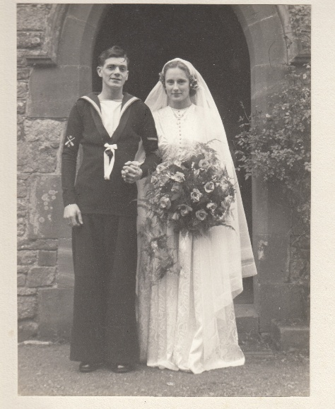
After the two and a half years, through mutual friends, I had met Frank and we decided to get married on 2 August 1952. He WAS a Geordie. His parents came from near Gateshead but there wasn’t any work for his Dad. Frank had been on National Service for two years in the army. When he finished his National Service he came out of the army and went into the Navy. We got married at Muncaster and went to Grange on our honeymoon.
On the Sunday morning we went for a walk along the promenade and Frank passed-out! What do you do when you’ve been married only a few hours and your husband passes out? Fortunately another couple was walking by and they got him on to a seat and got us a taxi and said “take him to the doctor’s”. I said we only got married yesterday and the taxi driver said “what did you do with him?” A few days before coming on leave to get married he’d had injections for going abroad so we think maybe that had something to do with it..
Then one of his fingers decided to go septic. We spent most of the day in Morecombe looking for a doctor who lanced his finger.
After that we came back to Ravenglass because my Mum hadn’t met Frank before that because he was stationed in Londonderry. We stayed for a week then went back to London. He was then stationed at Chatham.
Frank was in the navy for the first 10yrs of our married life.
After that Frank and I moved back to London. A school friend of my Dad’s owned a large house split into flats and we took one of those. £3.50 a week in Hounslow. After 10 months Frank was posted to Malta. You had to have been married 3yrs before the navy paid for wives fares so I paid all of £20 and flew out to join him in Malta. This was after the Queen and Phillip were there but the Queen did visit for a week or so while we lived there so of course that meant a lot of marching up and down for the boys.
Malta is quite rocky but a lot of us hired a coach and went off to find a sandy beach were we spent all day dipping in and out of the sea. There was no sun screen so I’m lucky I haven’t had a load of skin cancer. After being out all day in the sun your skin got quite hardened.
We lived in Malta for two and a half years. Then came back to the UK. Frank was at his base in Chatham and I took married quarters in Gillingham. I took a nanny job again with a family. Two boys. Dad was a colonel by the name of Smith the same as me.
Settling in Ravenglass:
Then some good news. A baby on the way. Me being pregnant. I was booked in to Canada House in Chatham for the birth. Six weeks before the birth the navy in their wisdom sent Frank abroad again. I was given four weeks’ notice to leave married quarters because you couldn’t stay in them without your husband being in the country. Charming wasn’t it?
I didn’t fancy looking for a flat with a baby on the way so came back to Ravenglass and lived with Mum and my sister. Robin was born in Whitehaven at the old castle hospital on 12th December 1957. His Dad didn’t meet him for 6 months when he was given two weeks leave.
A few months later a house, Ashlea, on Ravenglass Main Street, came on the market just a few doors down from Mum’s so, after talking to Frank I bought it for £285 – a fortune. It needed lots of work of course. A new roof, lots to do in the kitchen removing the old set pot gave us more room. A set pot was a cast iron bowl built into a brick surround with a fire under it and you boiled your washing in it. It didn’t have a bathroom so we converted the coal house and lavatory to make one.
Then some more good news, another baby on the way. Miriam was born at home on 12th September 1960. Frank was stationed at Rosyth up in Scotland but he met her when she was a couple of weeks old – not too bad. He left the navy 10 months later and found work at Sellafield in 1961. Stan Wilson’s Dad helped him in that respect because he worked there. Frank didn’t like it because he was stuck inside all day and he was used to being outside. He left and became a postman.
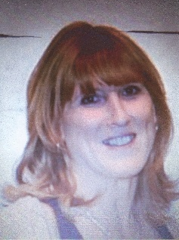
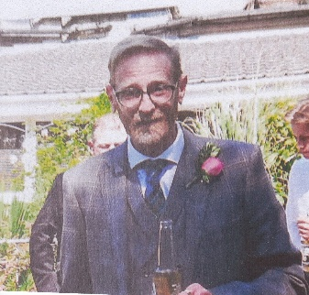
Betty’s children Robin and Miriam

Working Life: I didn’t work until both children had started school when I became the dinner lady at Muncaster school. I stayed there until the school closed (I can’t remember when that was).
We moved to Ravenglass in 1982 and it was closed then.
Around this time I was a member of the Church Council and the Parish Council.
After the school closed I worked at Woodall’s shop in Waberthwaite.
In 1983 Robin and Miriam both decided to get married. One in March and one in September. An expensive year. Three years later Owen who has Down’s syndrome was born to Robin and Nicola followed by Lee in 1987 and Lauren in 1990 to Miriam and Brian.
Later I worked as a guide at Muncaster Castle and was then asked to run the café because Mrs Caldrey who had run it for quite a lot of years had left.
When I was in my middle 50s the Day Center in Ravenglass was set up for “slightly older” people. We had 10 to 15 members and met every Monday, We did exercises, sang, played cards, dominoes etc. and had lunch provided by the Pennington Hotel. With help from various volunteers I organized it for 5yrs.
After that I went back to Muncaster to work with Ann Matterson in the garden center until I retired at 60.. I enjoyed that very much because I like gardening.
Speaking of Woodalls at Waberthwaite, I think the first time I came across you was when Ingrid and Rebecca were involved in a collision with a lorry down there and you helped them out.
Yes. I was just on my way home. Big lorries came to Woodall’s and the road was very narrow and I saw this big lorry. What happened, How were they involved?
Ingrid’s mother lived down at Eskmeals and they were coming back from visiting when this lorry reversed into the stationary car. You brought them home to Seascale. They weren’t injured but the car was.
Frank retired about the same time as me but he became increasingly ill and died from lung cancer in 1997.
Mum was showing signs of forgetfulness. My sister Ann came up from her home in Devon and the three of us had a lovely holiday touring Dumfries and Galloway before Mum got any worse.
For years Mum’s eldest brother Ernest and his wife Gwen had enjoyed coach holidays in Scotland. When Gwen died Ernest asked me to accompany him. We had six holidays over a few years going right up the west coast of Scotland, across the top and down the east coast. Our last trip was to Cornwall. On the first morning Ernest fell and broke his hip and spent the next five weeks in Truro hospital. Luckily I had friends in Cornwall so I spent time with them and wasn’t on my own too much.
After a few years Mum sold her house and moved in with me. She used to wake me up in the night not understanding why she was in my house and not her own. My brother Robert said to me once “You’ll be in your grave first if you carry on like this” So it was decided Mum should go to live in St George’s home in Millom where, two years later in 2003, she died peacefully aged 94.
In 2002 a more modern house in Ravenglass came on the market and I bought it, mainly to get away from the tide that flooded us now and again and I was getting past cleaning up after it. During my time in Ashlea we were flooded four times. Once it even washed our hutch of guineapigs off the wall. They were rescued but what do you do with eight or nine guineapigs climbing all over you with nowhere to put them in a flooded house? When I was young the water used to come up the street and it was quite fun. The flood defenses were put up in 1981 and that was a big help.
It still used to get in through the sea wall. Our bathroom was against the wall and when I went down the two steps I ended up to my knees in water. It was quite a big area of wall to be kept pointed and so on.
Did you hang your washing out on the Green at the back
I hung my washing out on the pully. It was great. You got a good breeze. Quite a few houses did as well. Nobody does it now.
I don’t suppose there’d be any holiday homes then? When did that start?
Now, I can’t remember but there’s too many of them now I think the village looks a mess. There’s more holiday homes than people living in them. Couldn’t support seven shops now. They bring everything with them. However, don’t get me on about that, Tourists are all well and good up to a point.
There was something about closing footpaths that your mother got involved in?
In 1960 Muncaster proposed closing footpaths and my mother was involved in a campaign against it. She went to court and swore that she’d walked these paths on a regular basis. Mrs Annie Preston was involved and Cora Wilson. They all went to court and won the case.
At another time there were efforts to stop people going onto the sand hills across the estuary. On a couple of occasions when I went over there some men told us we weren’t allowed but I wasn’t having that. It was something to do with disturbing the birds but we were just walking along the sand not going in where the birds were nesting.
Handicrafts:
All through my life I’ve done craft work. Knitting, crochet, beadwork, all sorts of things but my eyes won’t let me do that now. One day in 1996 when we were cleaning St Micheals and All Angels church we noticed the altar frontal was looking it’s age and fraying in places. So I came up with the idea of having a “12 Days of Christmas” carol tableaux to raise money to make a new one. I gathered together 10 other ladies of the parish to do something about it.
First we held a coffee morning to make enough money to cover the running costs and got to work. Each day in the carol was depicted in a different way as each lady had their own ideas on how it should be done.
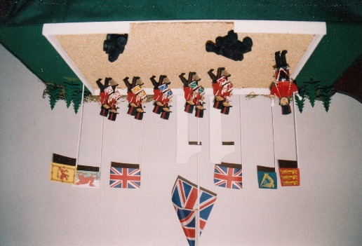
Came the day to put everything together in the church. To make a parade ground for her 11 drummers drumming Lillian Himsworth had used porridge oats. Upon entering the church next day we found it had gone – eaten by church mice. Next time she used sand and it stayed complete. The children of Waberthwaite School joined us and made 12 Pipers Piping. There would be some Ravenglass children attending Waberthwaite school after Muncaster school had closed.
We decorated the chancel and altar with flowers and some of the teenage girls embroidered the whole carol which stood in the porch.
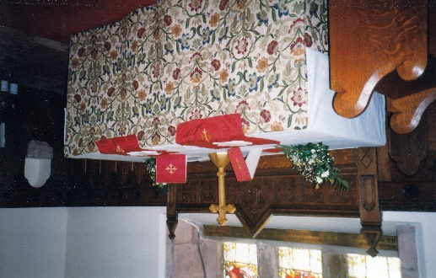
With the help of various husbands setting everything up we opened the doors to the public on 7th January 1996. They didn’t let us down and we raised £755. Then came the sewing part. We bought Portuguese Tapestry at £93.50 a yard for both the Frontal and Pulpit Falls. My cousin lent me her large sitting room for sewing days. Other ladies joined us and it all came together.
You can still be married or have a funeral at St Michaels Church now but the last Sunday Service was held at Christmas 2025.
Charter Fair:
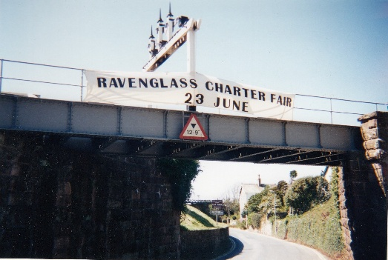
In 1996 it was decided to mark the granting by King John of a Market Charter for Ravenglass by holding a Charter Fair. Various events, stalls, children’s dressing-up and races and so on. A plaque was installed on Main Street. I didn’t join the committee but arranged for members of the Day Center to make bunting. Frank and I made the large banner which was fastened to the Ratty railway bridge.
Up to Date:
Anyway my house now has everything I ever wanted which was a small garden. It’s been my pride and joy for 24yrs now. In the last few years my granddaughter has married and given us all three more children Erin, Charlie and Ada. I’ve just had Ada here. She’s a force to be reconned with. I think she’s going to rule the world. She’s only 4 - but…
I’ve got three grandchildren, two boys and a girl and three great grandchildren two girls and a boy.
Sister Ann, her husband and their three daughters have visited for holidays either together or individually. The last time they were here was in May when the eldest of my sister’s children was 60. She brought 10 of her family and her Dad because her Mum died last year We ended that holiday with 15 of round a table at the Pennington. You couldn’t talk to the people at that end of the table. We all get on fine together. Ann and Robert have both gone now of course. So I live in happy retirement enjoying my children, grandchildren and greatgrandchildren and what comes next I don’t know. And that’s it.

