Ravenglass Salmon Garth
The following information was provided by Mr Arthur Wilson who was one of the last operator of the Ravenglass Salmon Garth in the 1970s
Historically there have been many fish traps or Garths in the Ravenglass Estuary and tidal stretches of its feeder rivers. As well as, at least, two in the Irt, one, referred to as the Monk Garth in the area where the estuary decants into the sea and one in the Esk up-stream of the present-day railway viaduct there was what is now referred to as Ravenglass Salmon Garth the remains of which can still be seen at low-tide in the lower stretch of the Esk near the present-day railway bridge over the track onto the shore from Walls Drive.
Both the Salmon Garth and that further up the Esk were established during the reign of King John (6 April 1199 until his death in 1216). Permission to operate the Salmon Garth was granted to Muncaster Estate and for that further up-stream to the Vicar of Bootle.
Garths operated by allowing fish to pass up-stream with the incoming tide but partially restricting their route back down-stream on the ebb tide. Fish then became trapped in a channel and pools behind the Garth and where caught by the operators using nets.
This illustration shows the Salmon Garth as a rather complicated structure and the details of its operation have been lost. The Garth as last operated in the 1970s was a simpler “V” shape with apex pointing down-stream and wings going out to the sand bank on the inland side of the river channel and to the shore near the Walls Drive bridge.
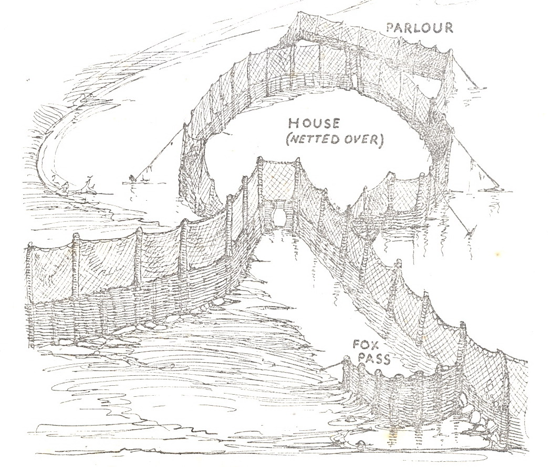

The Garth operated under a licence issued latterly by the Cumberland Rivers Authority. Fishing was effectively allowed only Monday to Friday. A gate at the apex of the “V” could be opened or closed to allow fish to pass through or not. The gate shouldn’t be closed until 12 noon on Monday and by 6am on Saturday it had to be opened. If the tide time was right a buoy with a long rope could be attached to the gate so drag of the tide pulled it closed.
No metal was allowed to be used in the Garth construction. The walls of the Garth were about 4ft high constructed of hurdles of “reches” woven between posts driven into the river bed sometimes with nets above the hurdles. Two inch gaps in the hurdles were required to allow small fish to escape – although fish tended not to be keen on swimming with the pull of ebbing water and ended up trapped anyway.
Operating the Garth was hard, physical, work. Tides ebb and flow at times that advance every day so fishing was twice a day at all hours of the day or night in all weathers. Tons of reching had to be cut every year to maintain the Garth and the nets had to be kept free of seaweed etc. otherwise the flow of water would break them down. Posts had to be replaced regularly although they tended to last many years.
The net used to haul the fish in was 75yds long and very heavy. When the time was right the operators walked the net around any fish that were trapped and then hauled it into shallow water. If there were more than one or two fish it was heavy work.
Arthur Wilson says “Tommy Raven and I once got 64 fish on a morning tide. We got two in the afternoon then none for a fortnight”. As well as the desired salmon, other species were often caught. “Whitebait by the hundredweight that were served up in the Pennington Arms bar. On a couple of occasions 6ft Tope Sharks Galeorhinus galeus, mackerel that nobody wanted and other strange fish with fins like legs” The Salmon were sent to Muncaster Castle or sold to local hotels.

Fishing the Garth finished in the late 1970s because of the decline in fish stocks and increase in license duty. The cost of the licence was £50 in the 1960s and increased to £65 in the early 1970s. On 1st January 1976, it went up to £100 and on 1st January 1978 to £130. In 1979 an application was made by Muncaster Castle Estates for a reduction in the annual licence duty on the grounds that its value to the Estate was of more significance historically than commercial. The request was turned down.

Cumberland River Board (1965) Fourteenth Annual Report for the year ended 31st March, 1965.
Year | Number Caught
1953 | 29
1954 | 18
1955 | 83
1956 | 36
1957 | 237
1958 | 144
1959 | 183
1960 | 90
1961 | 36
1962 | 78
1963 | 250
1964 | 159

SOUTH AND WEST CUMBERLAND FISHERIES ADVISORY COMMITTEE
held at 2.30 p.m. on MONDAY, 8TH JANUARY, 1979
A request has been received from the agents for Muncaster Castle Estates, the owners and licensees of the Ravenglass Salmon Garth, for a reduction in the annual licence duty of £130.
The duty was increased from £65 to £100 with effect from 1st January 1976 and to the present rate of £ 130 with effect from 1st January 1978. The agents complain that on neither occasion were they notified of the proposed increase nor were they aware of the press not ices regarding the increases published by the Authority in accordance with the statutory requirement. Had they been, an objection would have been lodged on each occasion.
The Salmon Garth is situated between high and low water mark on the right-hand bank of the Estuary of the River Esk at Walls Bridge near Ravenglass and is composed of stakes and hurdles with a neck or opening of four feet wide having perpendicular bars two inches apart. It is a fixed engine certified in pursuance of the Salmon Fishery Act 1865 to be a privileged fixed engine, within the meaning of the Salmon and Freshwater Fisheries Act 1975, section 6(3) (a).
In support of their request. for a reduction in the licence duty the agents argue that the operation of the garth and its value to the Estate is of more significance historically than commercially, as there have been Garths in the Esk Estuary since ancient times. In the last few years it has caught very few fish and they quote the figure of three to four salmon annually, and state that were it not for an arrangement between the Estate and its netsmen it would be impossible for the Estate to operate the Garth. In the opinion of the agents, the present licence duty is punitive and they suggest an annual licence duty of £25 as being appropriate in all the circumstances; due consideration being given to the fact that the Garth is now run principally as a working piece of history.
As members are aware, although presently the Authority is not reviewing the net licence duties, a review of the licence duties relating to rod and line is taking place. Consequently, and in view of the circumstances described, it has been agreed that the matter of the licence duty applicable to the Salmon Garth should be submitted for the consideration of the Committee. Any recommendation that might be made could then be placed before the meeting of the Regional Committee on 5th February 1979 with a view to its inclusion in the current licence duty review.
Committee refused to reduce.

